I was asked by Tracy Murphy from Lets Talk Terriers Magazine to write “My Life’s Journey with Tenterfield Terriers”
Let’s start at the very beginning, in the beginning there was ONE, known simply as “Tiny”. Tiny came to me along with my now husband Merv. Merv had a Mini Foxie (as they were known back then) for his truck dog. It was small didn’t take up too much room, or drop too much hair, yet would soon let you know if someone was around the truck. That would have been back in 1978, and that was the start of what’s become life’s passion, or obsession if you ask my husband. We lived in my grandparent’s old farm house on my parent’s farm for some years before buying our own home. I remember after a little time had passed Tiny actually disappearing when it was time for Merv to pack the truck and head off on his next Darwin trip. Once the truck had left the farm, out she would trot, so that told us she really didn’t want to go anymore.
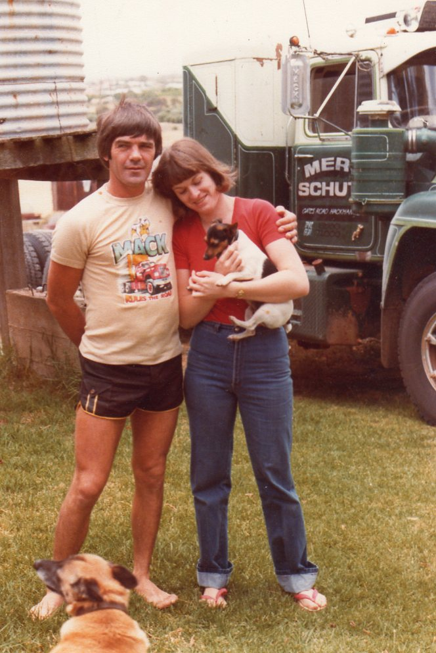 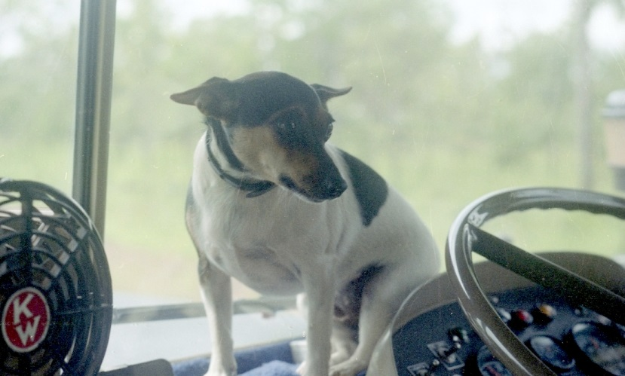
Original Tiny
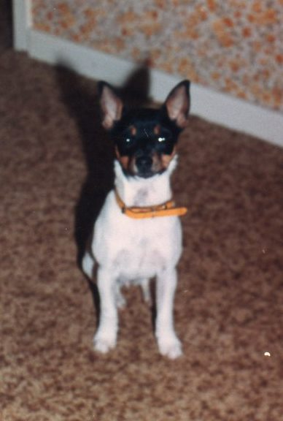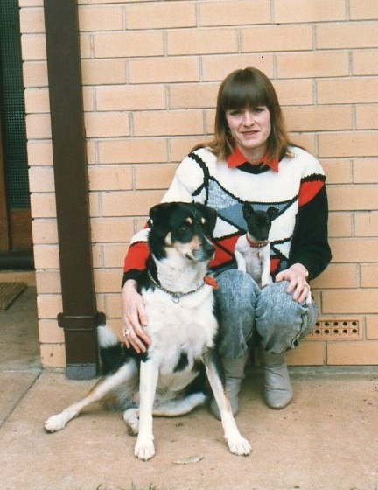
Midge myself, Baby BG Jesse and old Sammy A baby Blue Gum Jesse, enjoying some
sunshine
No 2 was Midge and no 3 Jesse. Jesse born 12/8/1989 was at a later date to become my foundation bitch within the Tenterfield Terrier Club SA, registered as Foundation Stock no 80 on 9/5/1994.
My first litter was with Jesse to a male we purchased Stumpie, the resultant litter was of 4 pups on 24/2/1991,(prior to joining the club) to which we kept one female and named her Tiny in memory of our first, which by this time had been to Rainbow Bridge for many years.
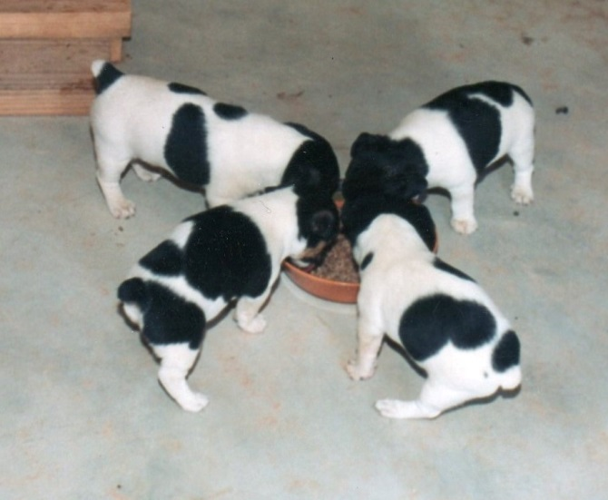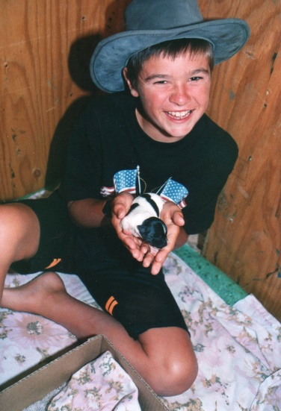
Jesse’s first litter. Blue Gum Tiny Left Front…… Ryan and one of the first litter.
I went along to a few club days held by the Miniature Fox Terrier Club SA, as it was then known, and at about that time my original dogs were club registered (listed) as Foundation Stock under my club prefix Blue Gum. Shortly after the Miniature Fox Terrier Club SA had a name change to the Tenterfield Terrier Club SA, but that’s a whole other story, same dogs, new name.
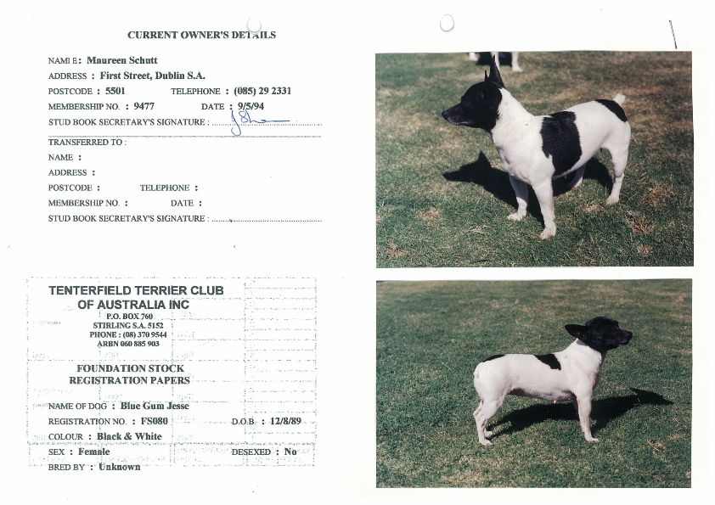
Not great photos of Jesse.

My next addition was Blue Gum Max, who was my son Clay’s first dog. They did everything together, Max became his shadow.
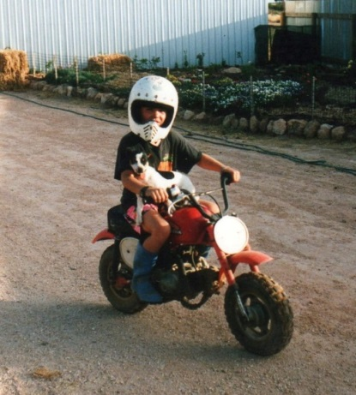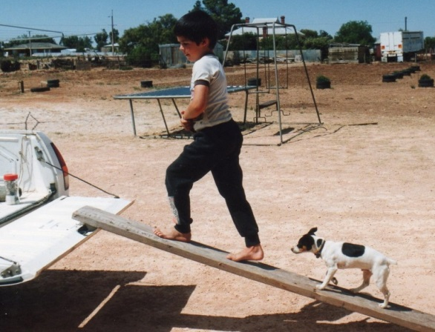
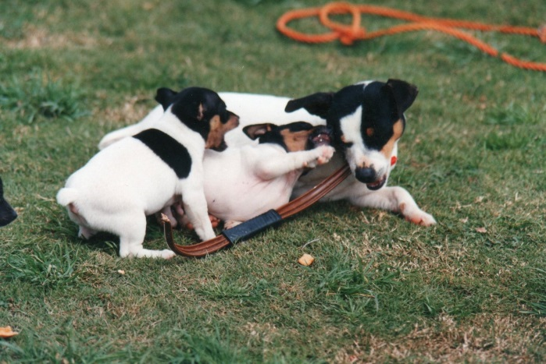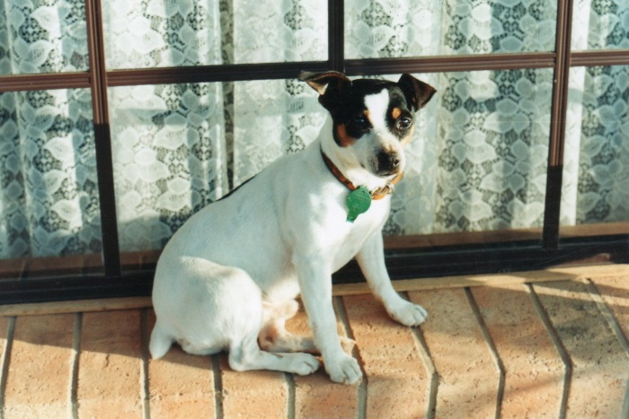
Blue Gum Max and 2 of his kids. BG Max
Needless to say after that I was definitely hooked, I just loved the dogs and breeding. I have all my records from 1994 of every mating and pup born here, all were club registered until we gained recognition by the ANKC in 2002. That’s when I became Gumhaven Kennels, as I couldn’t get my club prefix Blue Gum, I had to choose another. I have included some club information here as the club was and still is a big part of my life.
We were permitted to use Dogs SA judges at our Tenterfield Terrier Club Of SA club shows which always had a great turnout, usually around 70-80 dogs. We had a show every 2 months and some fun days along the way. I became more involved in the TTCSA going on committee in 1994, Vice President in 1998 and President since 1999.
During that time The Tenterfield Terrier Club of Aust held 3 National Shows (pre recognition) the 1st in 1997 with 250 dogs split over two days. The 2nd in 1999 with 350 dogs also split over two days. The 3rd was in 2001 also split over two days. Probably my most memorable one was the 1999, as at those shows we invited the Presidents of all the state canine associations and had a special meeting to tighten up our standard under their guidance, 5 were able to attend. I have included a picture taken at the show. It got us all together and achieved a lot in regard to the standard as well as being able to show off these great little dogs to some very important people and to show just how serious we were about gaining ANKC recognition.
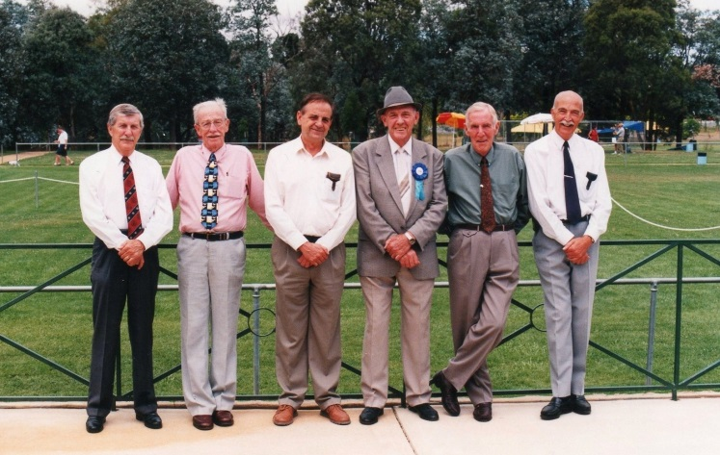
I also attended a meeting in Canberra where John Allen mediated a meeting between the Miniature Fox Terrier Club and Tenterfield Club trying to bring the two together.
In 2002 Tenterfield’s received recognition by the ANKC allowing us to move on from club shows to regular Canine shows.
My first bitch to gain her Championship title was Fernlodge Contessa which I purchased from Jan Thomas. Tessa is still alive and living the life of luxury in NSW with a friend’s mother at the ripe old age of 15.
My first boy titled was Zakaria Sheahan purchased from Di Cannon in NSW. I was very lucky to get this stunning boy, and still to this day was one of my favourites. Sheahan was a great asset to my kennel, he did me proud on many occasions, taking out BOB’s at Royal level, and producing some lovely pups along the way. He was BOB at Melbourne Royal and one of his sons Ch Gumhaven Man Of The Hour “Manny” was Best of Breed at Sydney Royal in 2005. The one and only time I have done Sydney Royal.
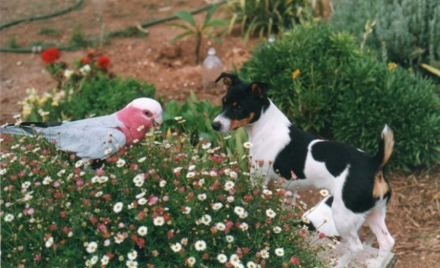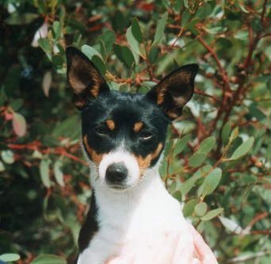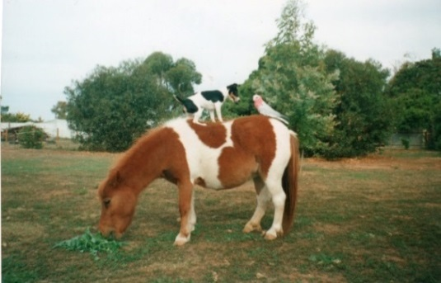
Ch Fernlodge Contessa……………..Tessa and friends
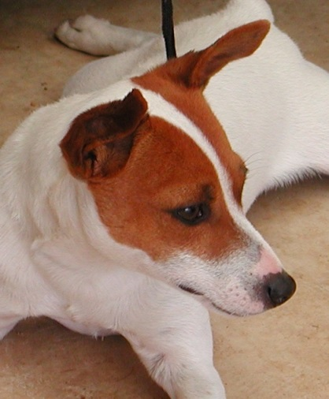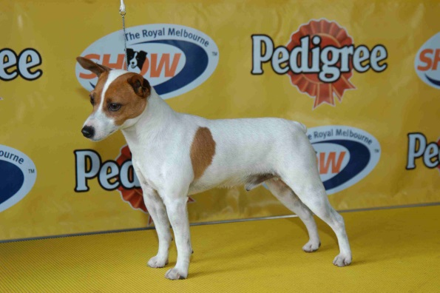
Ch Zakaria Sheahan
Along the way there are some special ones that touch your heart just a bit more than others. Ch GH Snowdrop, gave me some of my favourite progeny, one being Ch GH Logan, Ch Gumhaven Topaz, she was quite a clown her face and her Character , Topaz’s daughter Ch GH Crossing Jordan.
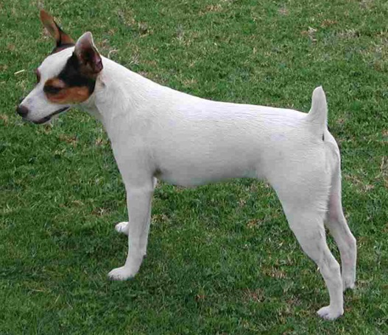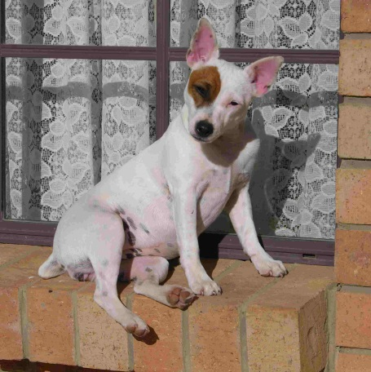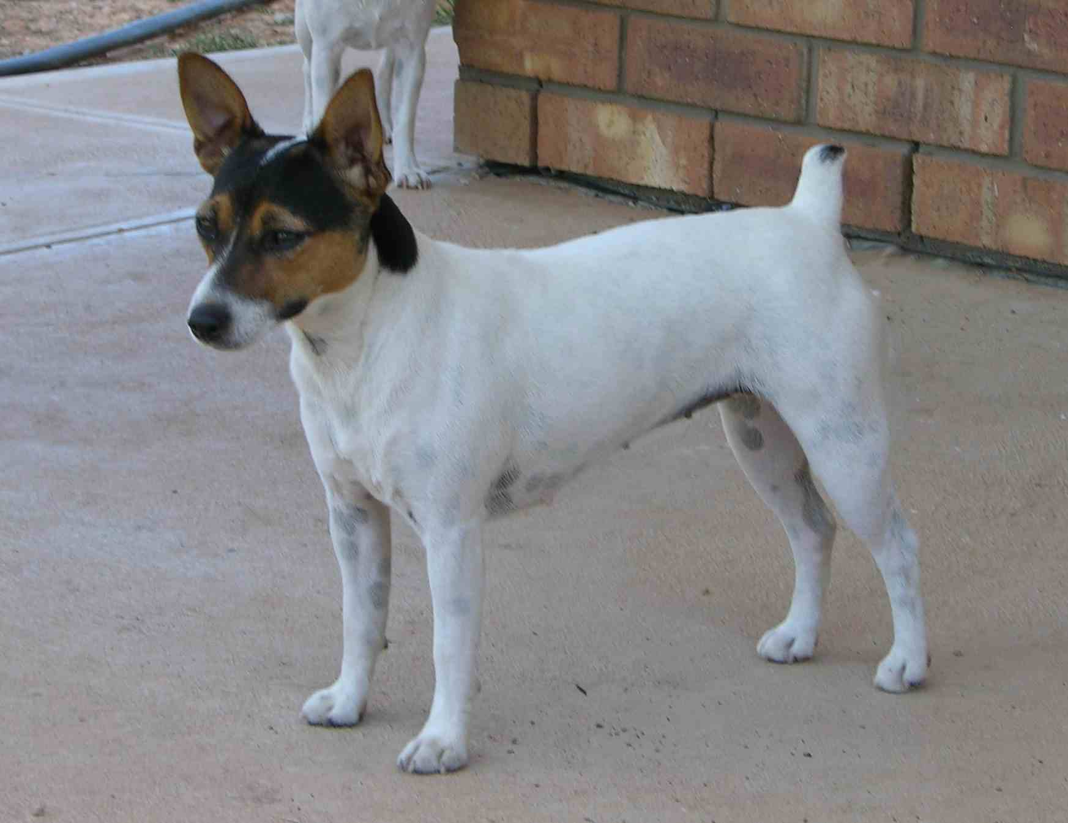
3 generations of girls here. L to R Grandma Snowdrop, Topaz and daughter Jordan.

One of my regrets is not taking Ch GH Logan through to his grand title, at the time I was more interested in bringing young pups up through the ranks than getting Logan’s Grand up, but in hind sight he so deserved it, I should have followed it through.
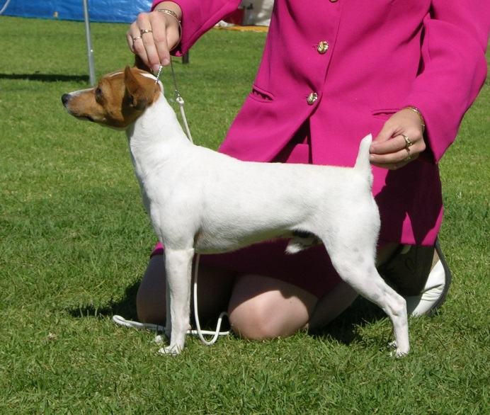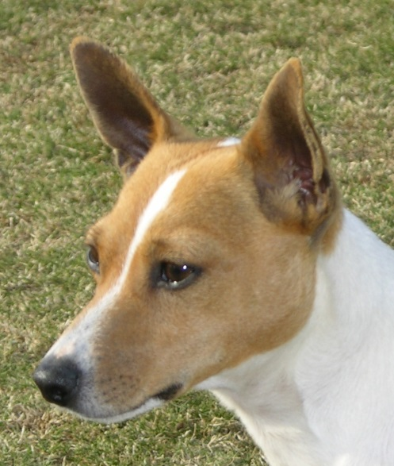
Ch Gumhaven Logan

Over the years I have bought in some dogs from other states to bring in new bloodlines, probably my most successful is Gr CH Doubleg Single Malt “Whisky”. I took Whisky through to his Grand, his last points gained on 18.8.12 at 2 yrs 5 months of age. Whisky is producing some lovely pups, and at present I am showing two of his Grandkids. Ch GH Chasing Stars who is on over 600 points at 18months old, and Ch GH Sand Piper on over 200 points at 12 months old. Chase was Best ISS Adelaide 2013 and Piper BOB at Melbourne Royal and R/UP BOB at Adelaide Royal 2013
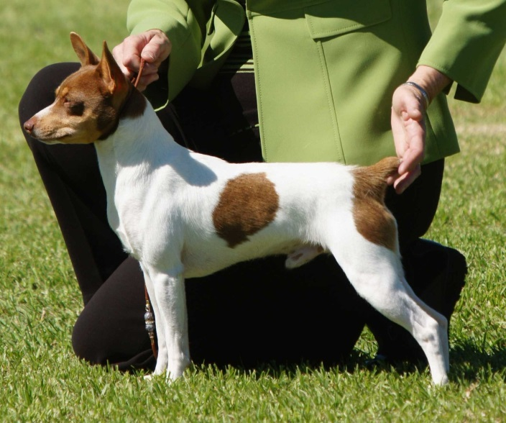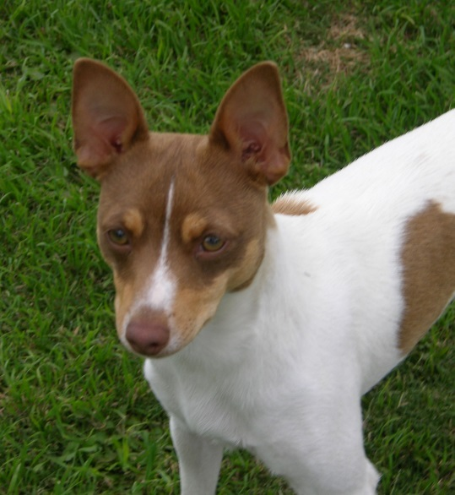
Gr Ch Doubleg Single Malt
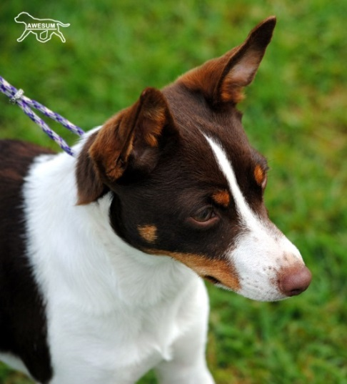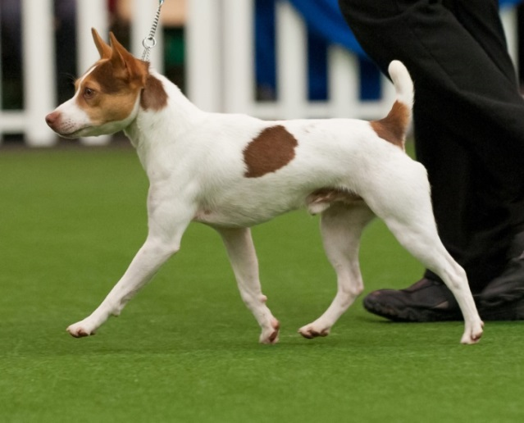
One of Whisky’s progeny doing well is GH Edge Of Glory “Pinky” Ch Gumhaven Chasing Stars
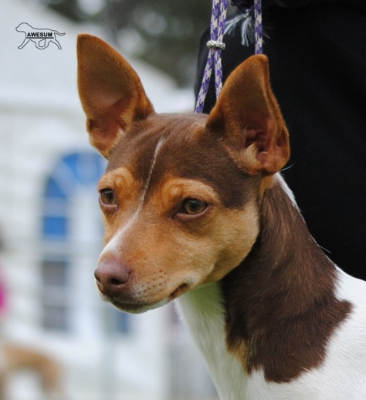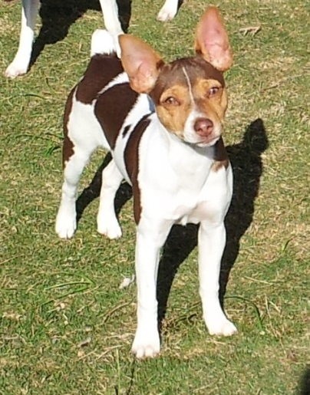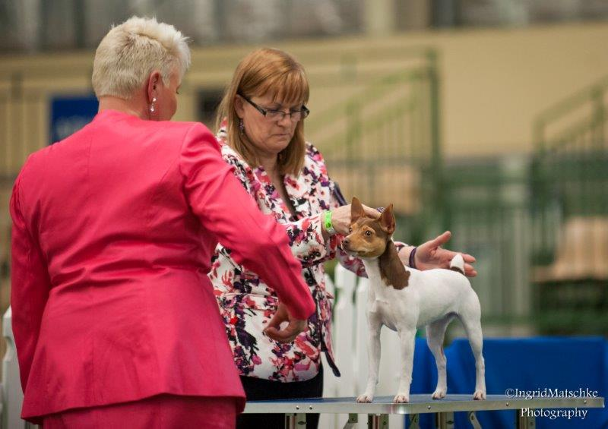
Ch Gumhaven Sand Piper (Judge Mrs Wendy Baker)
The majority of the people I have met along the way are very nice people. I find many willing to help out when I am showing, rocking up ring side when needed. One in particular Kerry Althoff (she has Staffordshire’s) is always there to lend a hand. Kerry was in Melbourne for this year’s Royal and came to the TT Specialty to help me, for which I am extremely grateful, it makes such a difference having someone to help that knows which dog is which and the dogs are familiar and comfortable with. Kerry got Best ISS with Ch GH Twist and Shout, not bad for a bitch that had puppies just 3 months before. Kerry has handled Twistie since she was a baby, and we always call Twistie “her dog”.
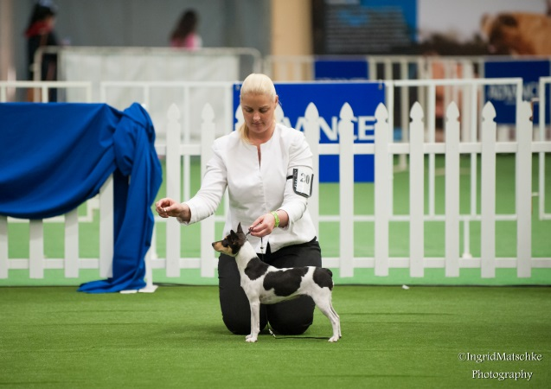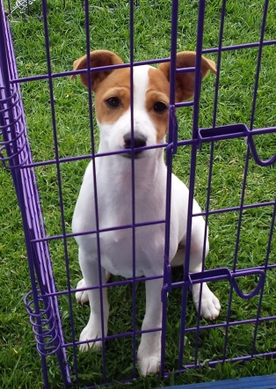
Kerry Althoff with Ch Gumhaven Twist and Shout at One of Twistie’s puppies Gumhaven Rolls Royce,
Adelaide Royal 2013. Twistie is by GH Grand Finale, sired by Ch GH Logan
sired by Gr Ch Doubleg Single Malt
National Tenterfield Terrier Council (Aust) basically took over from The Tenterfield Terrier Club Aust (short version of events) and held its inaugural meeting Jan 20th 2006. I was appointed Acting President after the retirement of Gary Fulton (WA) on March 15th 2009, and then President since Jan 3rd 2010.
Highlights of my time in the ring would be 9 Royal BOB’s, 13 Royal R/UP BOB’s and a Baby in Group at Perth Royal with Ch GH Hunters Nelson.
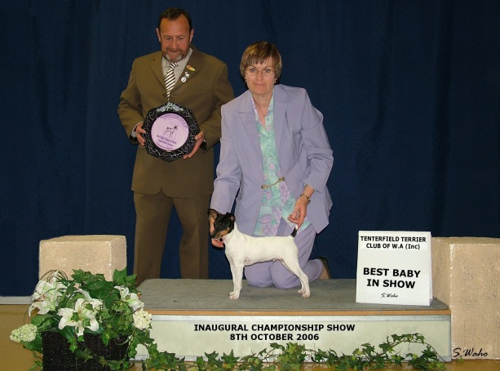 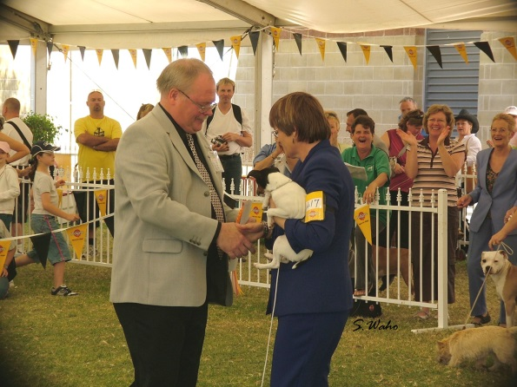 GH Hunters Nelson
As for Specialties, I’ve just had to go through some paperwork as I never had a result sheet for specialties. I found 7 Best Is Specialties and 4 R/Up BISS. I may have missed some I’m not sure.
I find judges more accepting of TT’s now as more time has gone by and the quality of dog getting better. I have had several Best In Groups and Runner Up Best In Groups at all breeds shows. As for class in groups, I think we get as many as any other breed now.
Whilst I quite enjoy showing, its breeding I really love, studying pedigrees and lines and putting them together. Then there’s the puppies, just love the babies. Tenterfield’s are in general great mums, Ch GH Gypsy Rose pictured after jumping in the puppy yard during puppy play time and just feeding the lot, then she jumped out again.
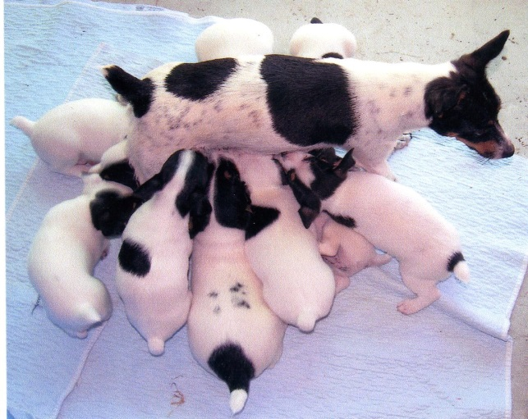 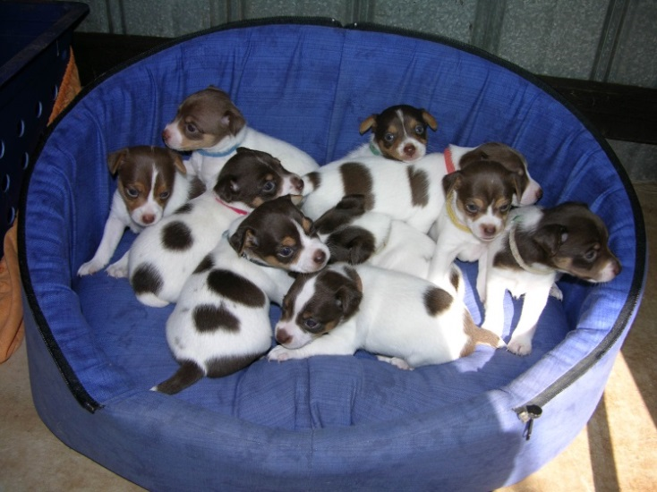
Right: One giant litter, Lawofnature Heat Haze “Fudge” presented me with 10 puppies in one litter, sired by
Gr Ch Doubleg Single Malt “Whisky”. Liver to liver mating so all livers.
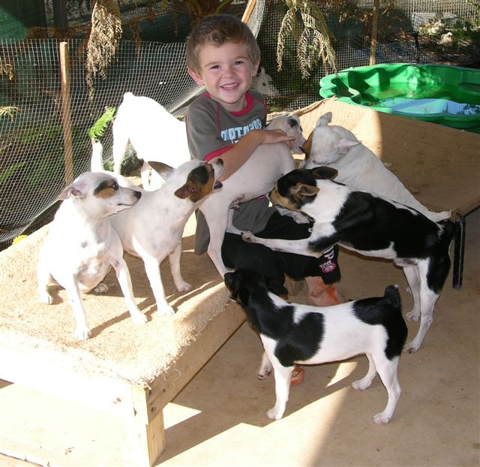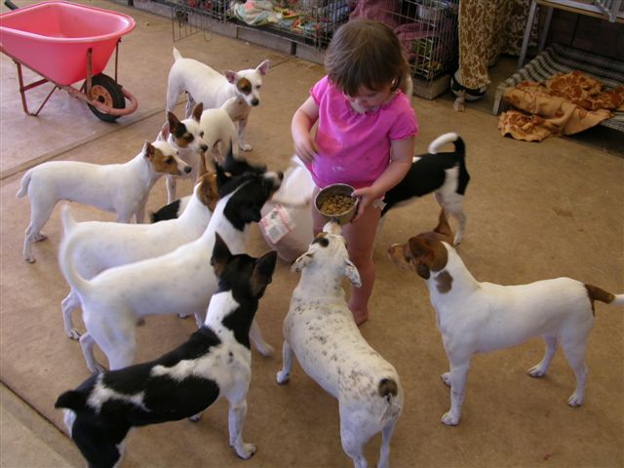
Grandkids Shannon and Jorja just love the dogs.
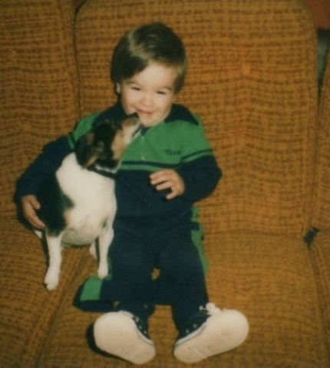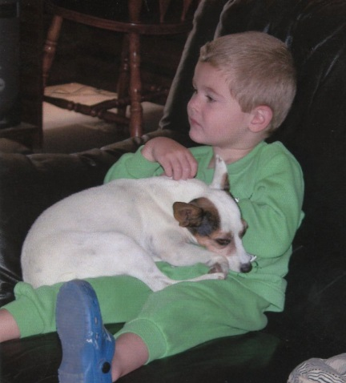
Like father like son, my son Ryan with original Tiny (left). Ryan is now 33 years old and his son Shannon (now 8 years old) with Ch GH Snowdrop (right)

As you can see by the photos, my love of the breed has spanned the generations, from ours to my sons to our Grandkids.
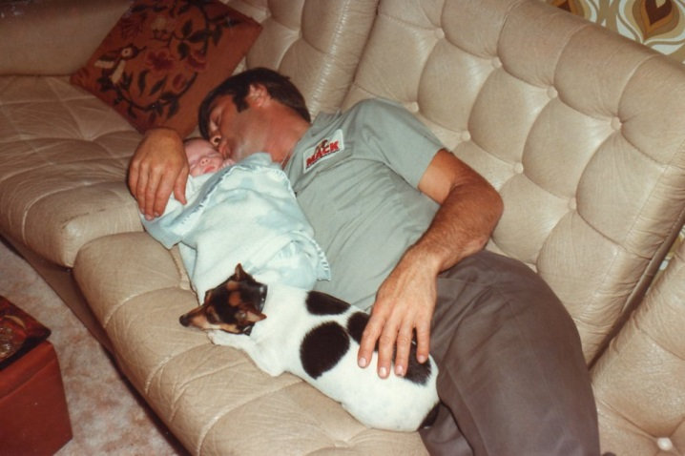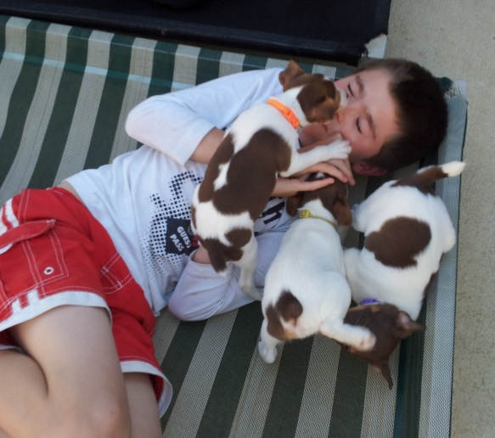
Husband Merv with our 2 kids. Newborn Ryan and Tiny, some 33 years ago. Shannnon
I find TT’s mix well with each other as well as other breeds also.
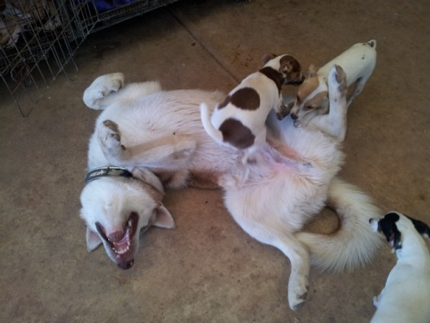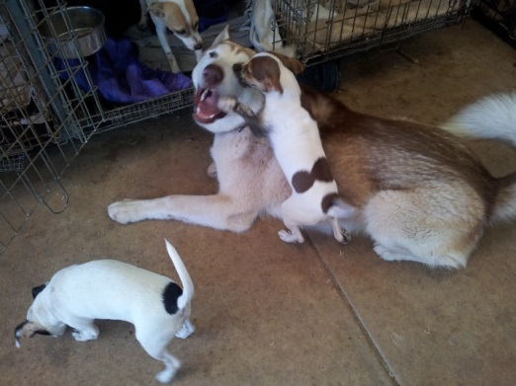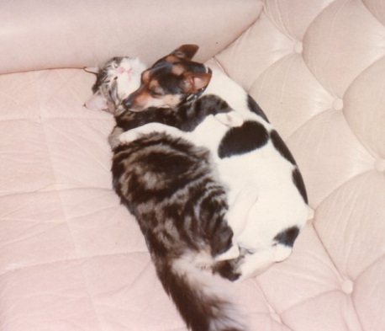
Babies playing with Alaskan Malamute Teeko
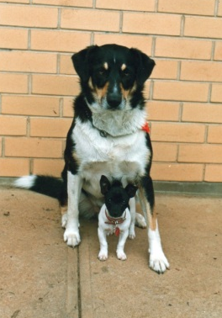 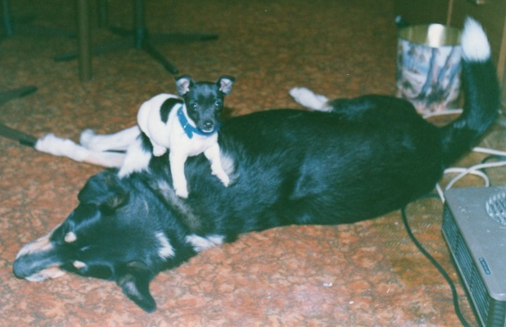 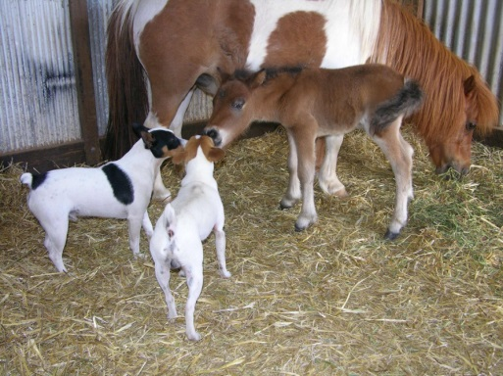 BG Jesse and Sammy Logan and Bandit meeting the new Foal.
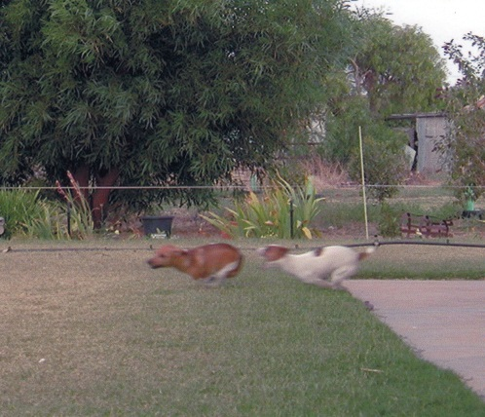 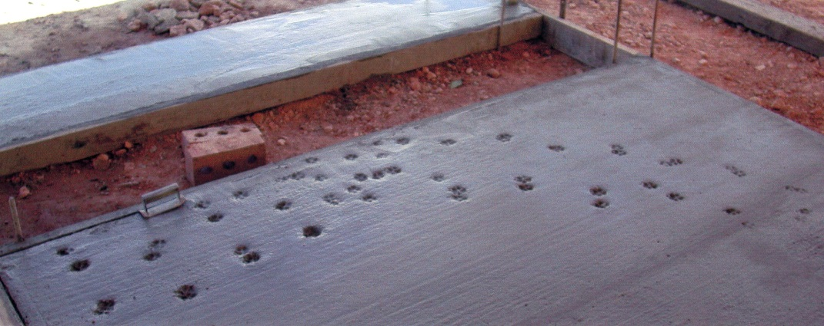 Oops Dogs too fast and we weren’t fast enough….. wet cement
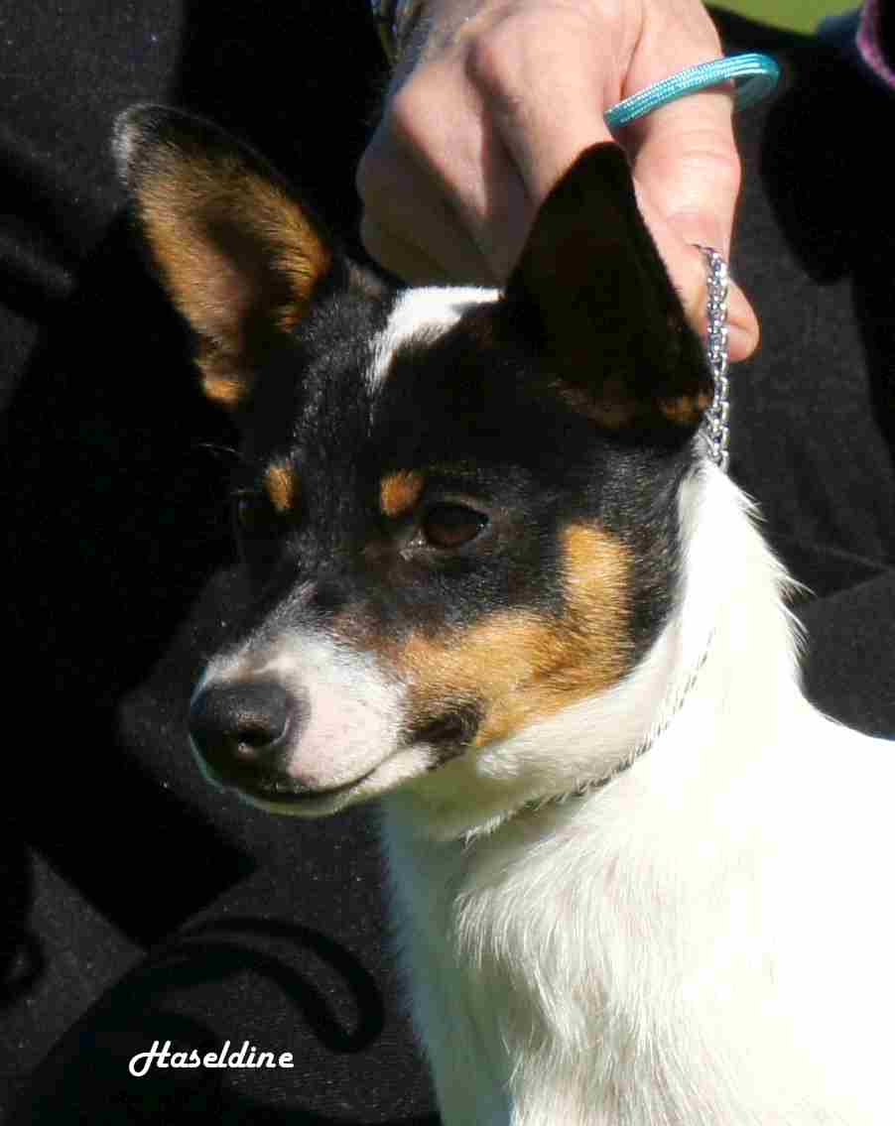 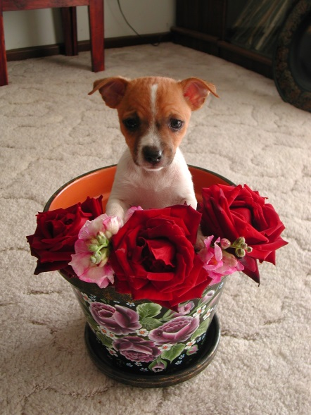
GH Mira Image Gumhaven Banjo Paterson GH So Pretty
I am truly blessed to have found these wonderful dogs and done so well with them over the years. Having them has given my life so much pleasure and direction.
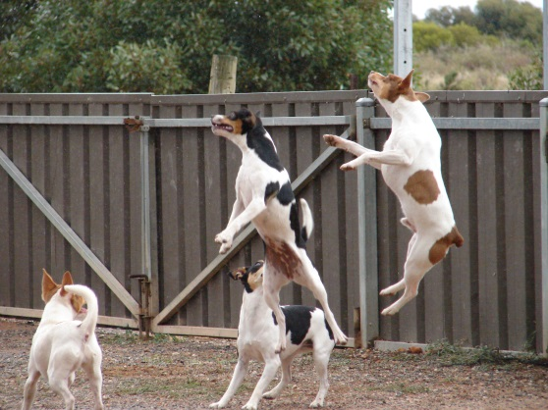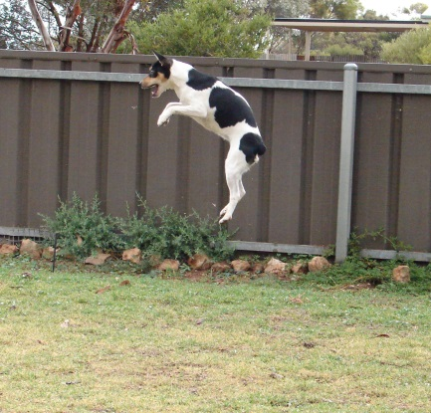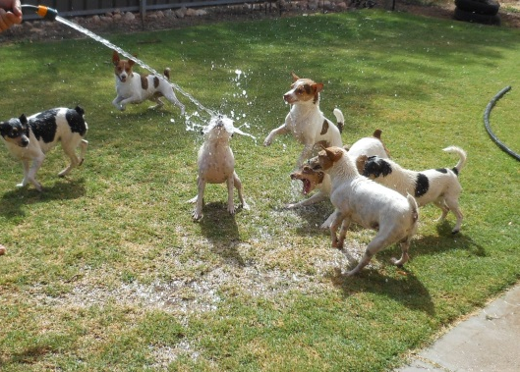
Chasing bugs They all love the water
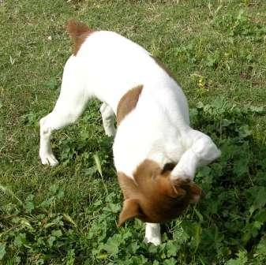
That’s all for now, Take a bow Whisky
Ch GH Cadbury Wispa
maureen@gumhavenkennels.com
0885292331
Maureen Schutt-Gumhaven Kennels
www.gumhavenkennels.com

